Instructions for installing Visual Studio Code extensions using a local file

The desired extension must be downloaded via the Visual Studio Marketplace: <https://marketplace.visualstudio.com/VSCode>

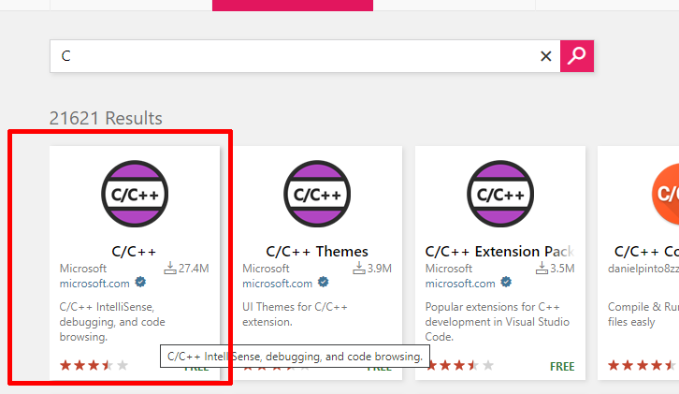 The Marketplace should be searched for the desired extension. An example of an extension for the C/C++ programming language is shown in the figure:

Then, on the extension page, you need to select *Download Extension* and select the operating system you are using. The example shows the case for Windows x64:

Slika na kojoj se prikazuje tekst

Opis je automatski generiran

The *.vsix* file should start downloading automatically. **Do not run the file.**

In VS Code, you need to select *Extensions* and click on the button with the three dots:Slika na kojoj se prikazuje tekst, snimka zaslona, crno, zaslon

Opis je automatski generiran

It is necessary to select from the drop-down menu the *Install from VSIX…* option:

Slika na kojoj se prikazuje tekst

Opis je automatski generiran

Then you need to select the downloaded *.vsix* file and wait for the installation of the extension to finish.

**Note**: These instructions also apply when the Visual Studio Marketplace is not available to you, but only the alternative source offered on the subject for downloading the *.vsix* file.